**1)**

Date: 09/08/2021 Exp. 2 Testing and Troubleshooting of Diodes, Zener Diodes and Transistors



**Aim:** To learn the testing and trouble shooting of Diodes and to obtain diode characteristics (V-I).

**Software/Hardware Components used:** LTSpice, 1Resistor, 1 Voltmeter, 1 Diode, Ground, Wire

**Circuits and Plots:**

**Circuit**

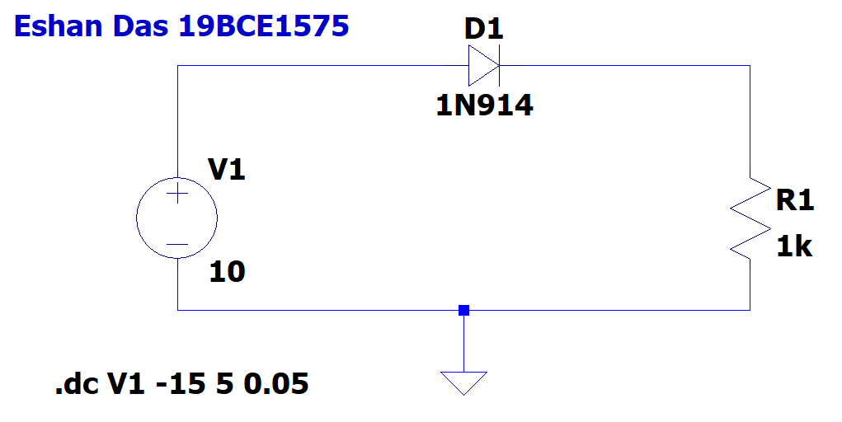

**Plot**

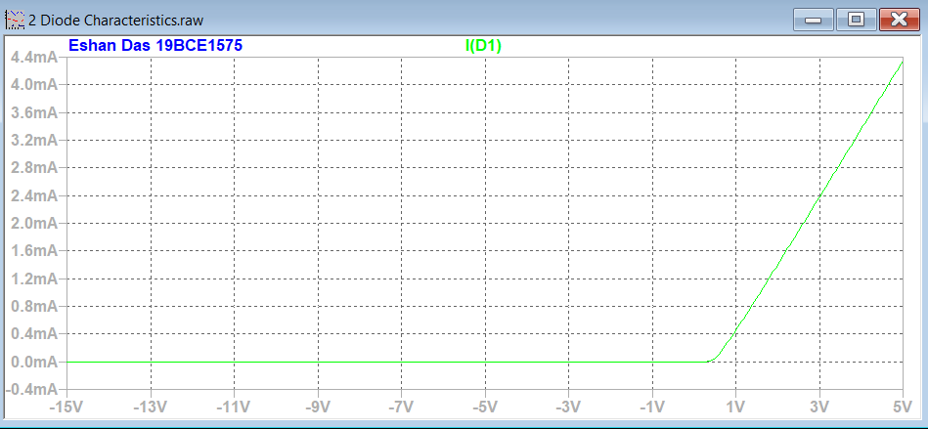

**INPUTS AND OUTPUTS:**

**Inputs**

|  |  |
| --- | --- |
| **Components Used** | **Input Value** |
| V1 | 10V |
| R1 | 1K Ohm |
| D1 | 1N914 |

**Conclusion:** Hence we are able to obtain the diode characteristics. (V-I)

**2)**

**Aim:** To learn the testing and trouble shooting of Zener Diodes and to obtain VI characteristics of Zener Diodes (2 diodes).

**Software/Hardware Components used:** LTSpice, 1Resistor, 1 Voltmeter, 2 Diodes, Ground, Wire

**Circuits and Plots:**

**Circuit 1**

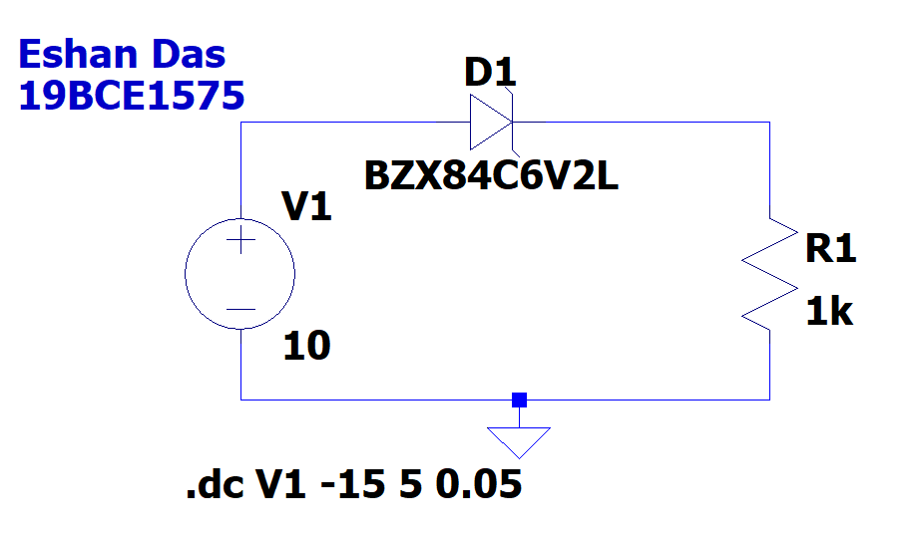

**Plot 1**

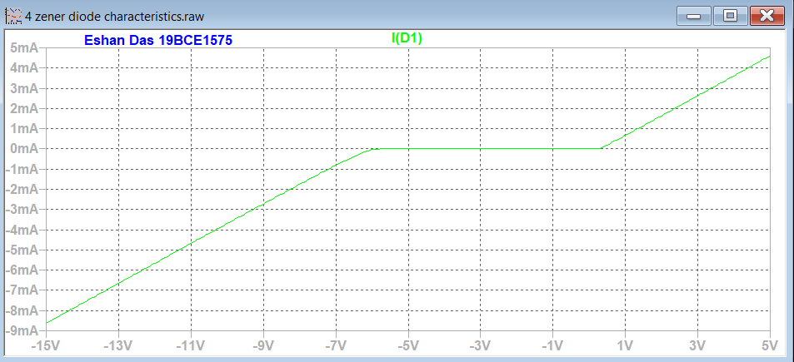

**Circuit 2**

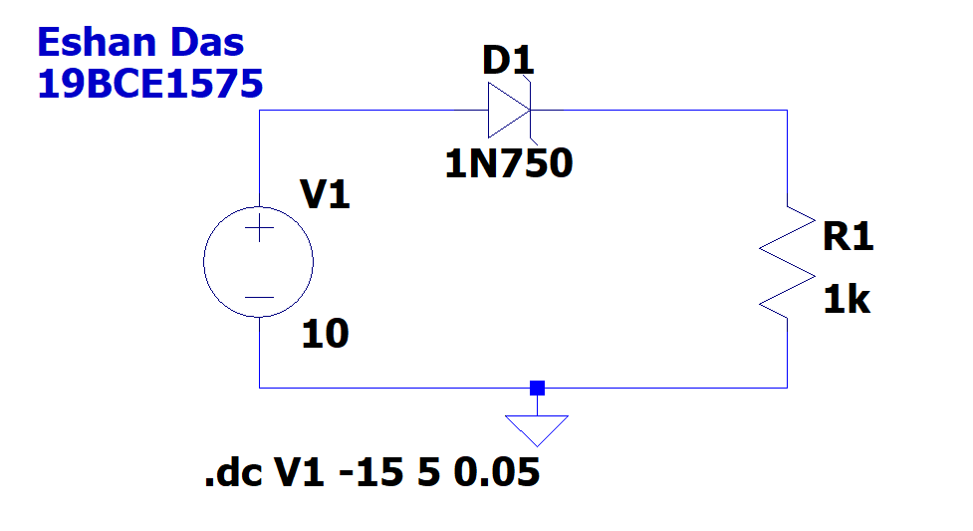

**Plot 2**

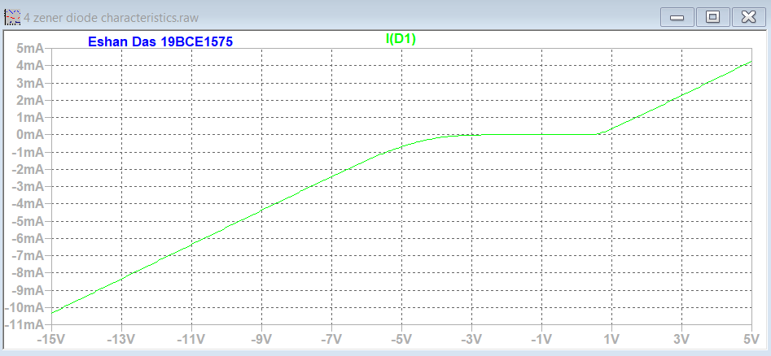

**INPUTS AND OUTPUTS:**

**Inputs**

|  |  |
| --- | --- |
| **Components Used** | **Input Value** |
| V1 | 10V |
| R1 | 1K Ohm |
| D1 | BZX84C6V2L, 1N750 |

**Conclusion:** Hence we obtain the VI Characteristics of the zener diode.

**3)**

**Aim:** To learn the testing and trouble shooting of Transistors and obtain Input and output characteristics of NPN Transistor circuit with:

a) CE configuration

b) CB configuration

c) CC configuration

**Software/Hardware Components used:** LTSpice, 2 Resistors, 2 Voltmeters, 1 Diode, Ground, Wire

**Circuits and Plots:**

**Circuit 1 (Transistor in CE: Input Characteristics)**

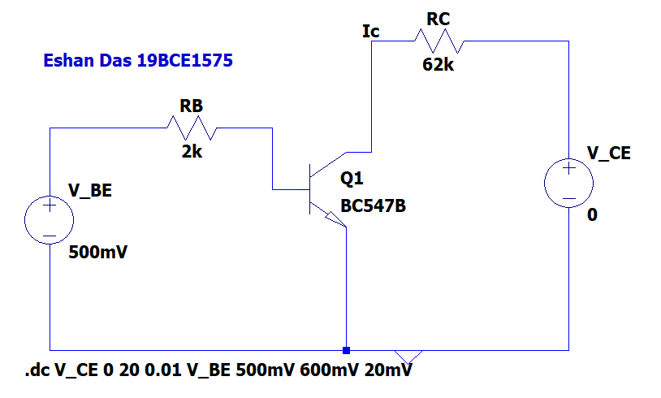

**Plot 1 (Transistor in CE: Input Characteristics)**

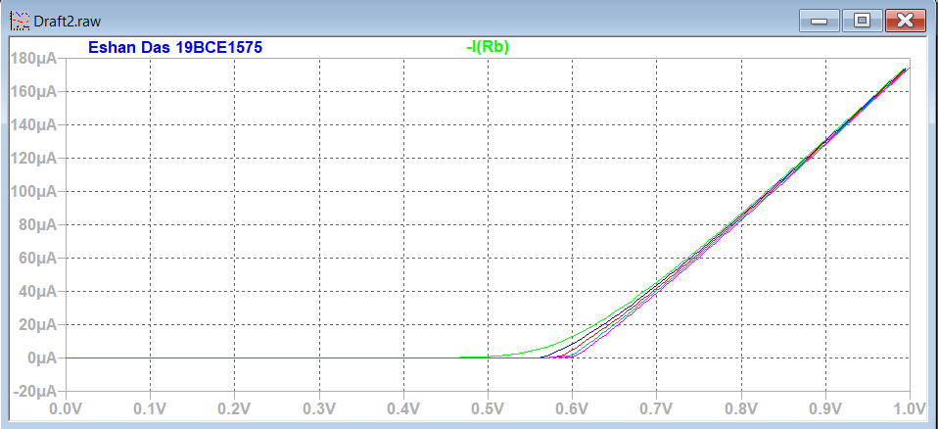

**Circuit 2 (Transistor in CE: Output Characteristics)**

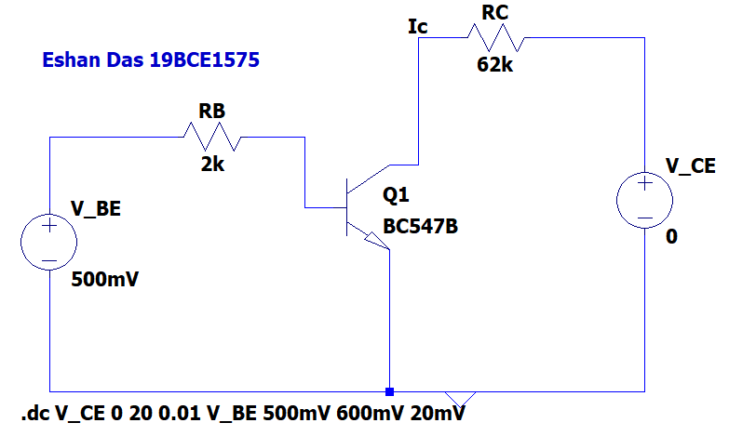

**Plot 2 (Transistor in CE: Output Characteristics)**

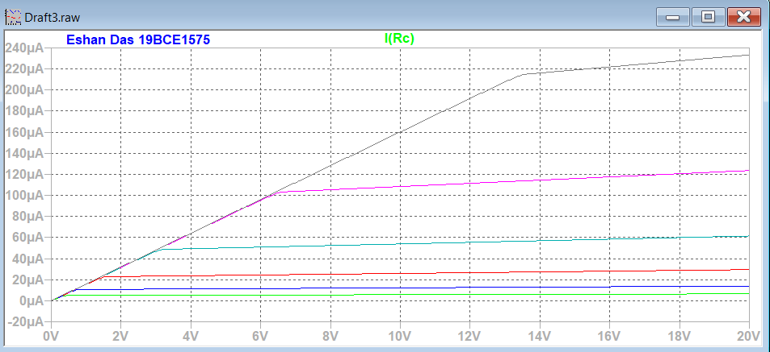

**Circuit 3 (Transistor in CB: Input Characteristics)**

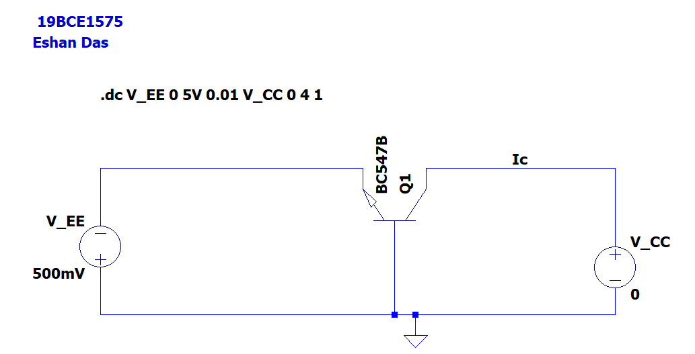

**Plot 3 (Transistor in CB: Input Characteristics)**

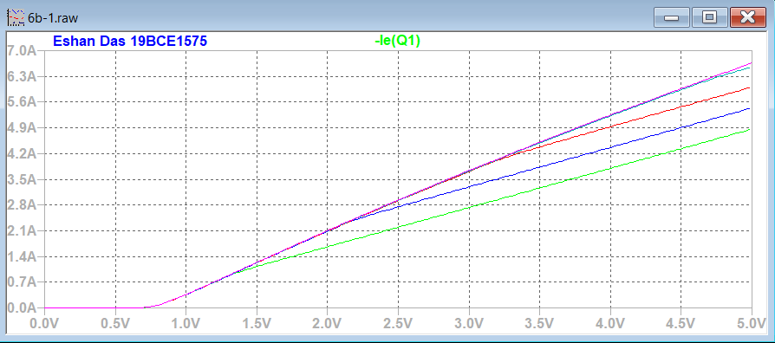

**Circuit 4 (Transistor in CB: Output Characteristics)**

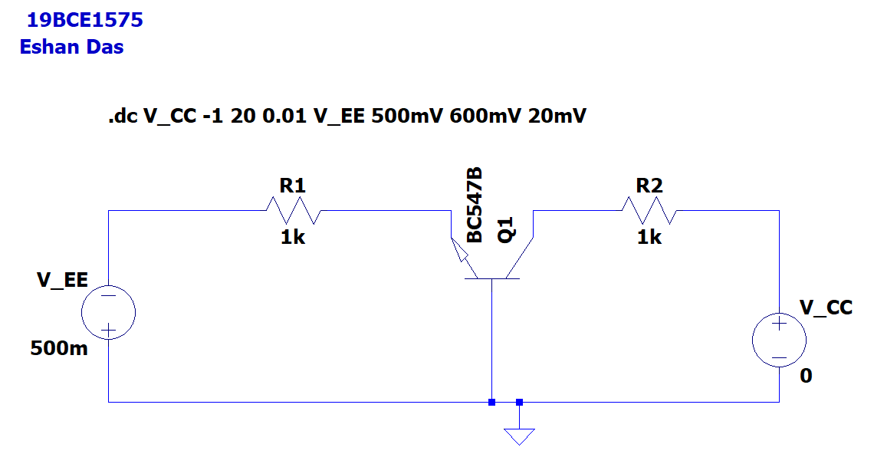

**Plot 4 (Transistor in CB: Output Characteristics)**

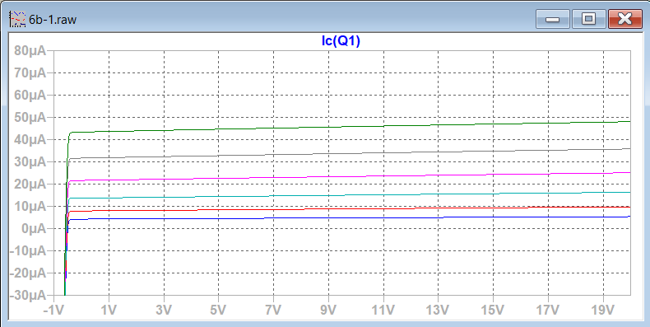

**Circuit 5 (Transistor in CC: Input Characteristics)**

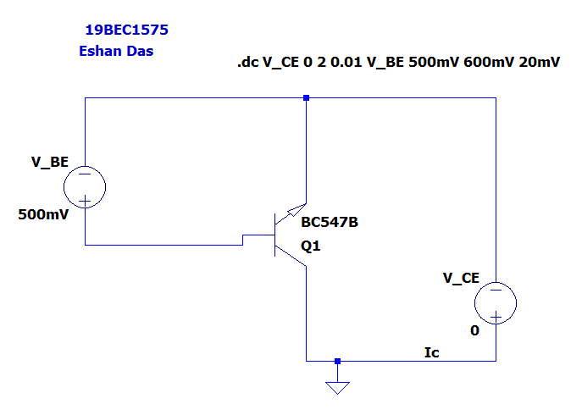

**Plot 5 (Transistor in CC: Input Characteristics)**

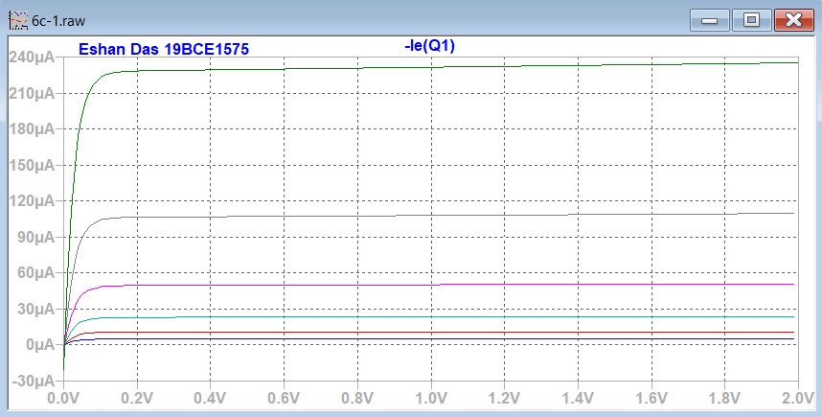

**Circuit 6 (Transistor in CC: Output Characteristics)**

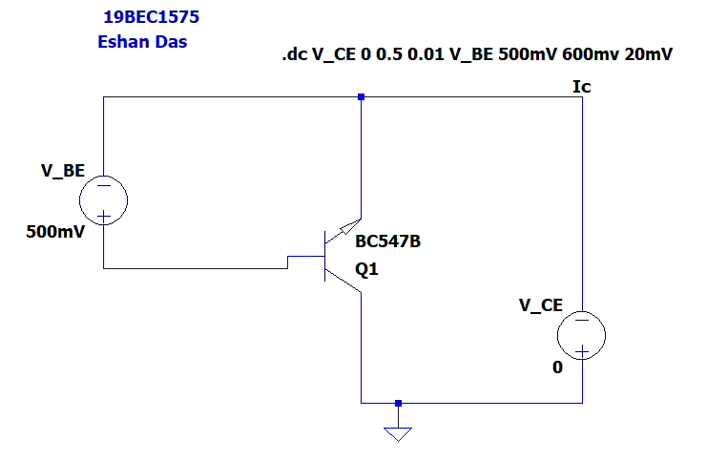

**Plot 6 (Transistor in CC: Output Characteristics)**

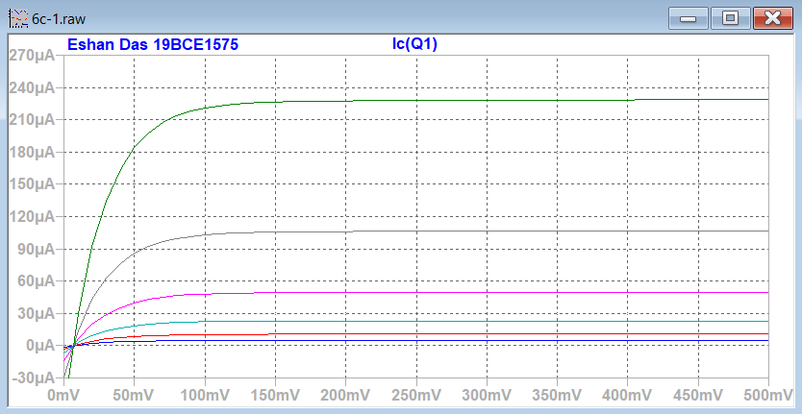

**INPUT AND OUTPUTS:**

|  |  |
| --- | --- |
| **Components Used** | **Value** |
| V_CE | 12  Start Value: 0  Stop Value: 16  Increment: 4 |
| V_BE | 0  Start Value: 0  Stop Value: 1  Increment: 0.01 |
| RB | 2k Ohm |
| RC | 62k Ohm |
| Q1 | BC547B |
| V_BE | 500mV  CE Output Characteristics:  Start Value: 500mV  Stop Value: 600mV  Increment: 20  CC Input and Output Characteristics:  Start Value: 500mV  Stop Value: 600mV  Increment: 20mV |
| V_CE | 0  CE Output Characteristics:  Start Value: 0  Stop Value: 20  Increment: 0.01  CC Input Characteristics:  Start Value: 0  Stop Value: 2  Increment: 0.01  CC Output Characteristics:  Start Value: 0  Stop Value: 0.5  Increment: 0.01 |
| V_EE | 500mV  Input Characteristics:  Start Value: 0  Stop Value: 5V  Increment: 0.01  Output Characteristics:  Start Value: 500mV  Stop Value: 600mV  Increment: 20mV |
| V_CC | 0  Input Characteristics:  Start Value: 0  Stop Value: 4  Increment: 1  Output Characteristics:  Start Value: -1  Stop Value: 20  Increment: 0.01 |
| R1 | 1k |
| R2 | 1k |

**Conclusion:** Hence we obtain the Input and output characteristics of NPN Transistor circuits.